HARDWARE INFORMATION

====================

CPU Information

====================

Task: To Display CPU information

command: cat /proc/cpuinfo

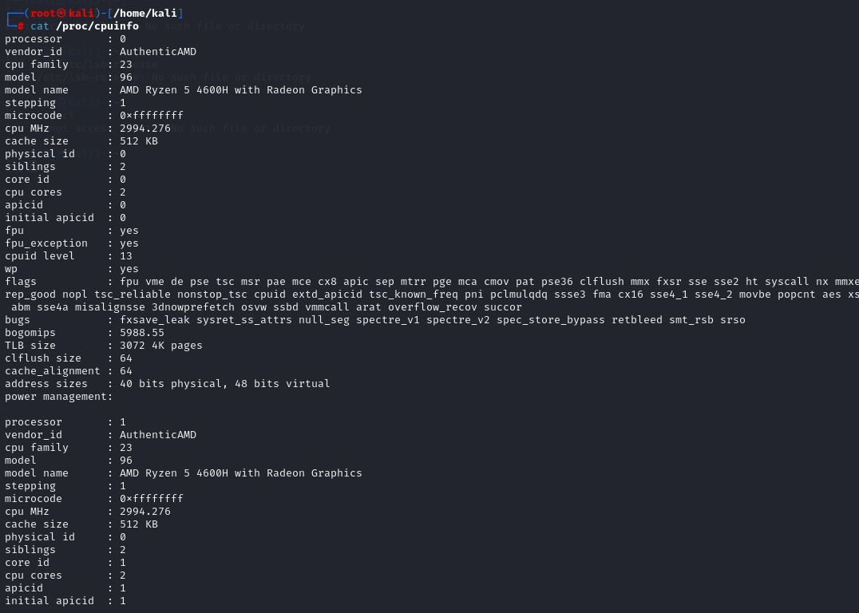

Task: To check cpu speed

command : lscpu

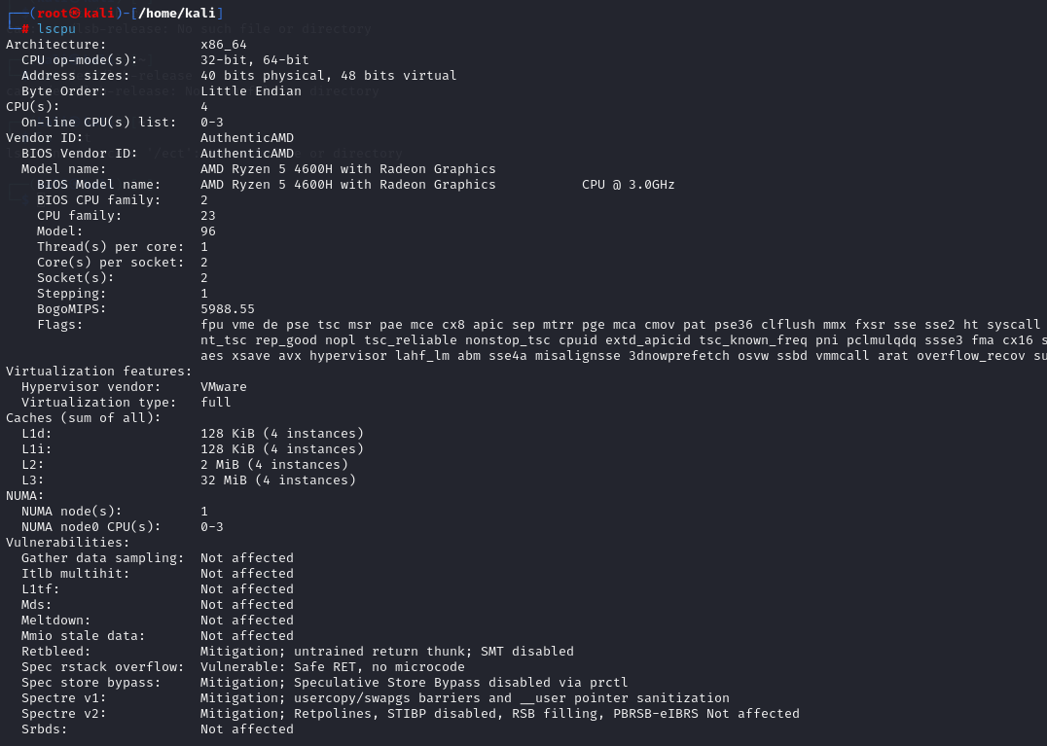

=======================

Memory Information

=======================

Task: To Display memory information

command: cat /proc/meminfo

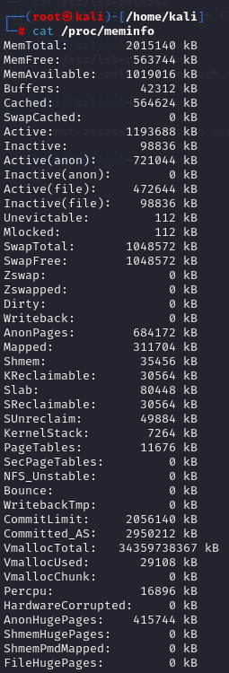

Task: To Display free and used memory ( -h for human readable, -m for MB, -g for GB.)

command: free -h

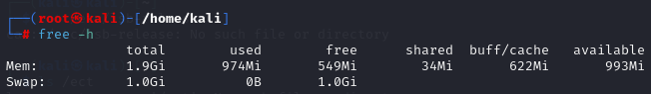

Task: To list each memory stick

command: dmidecode -t memory | grep -i size

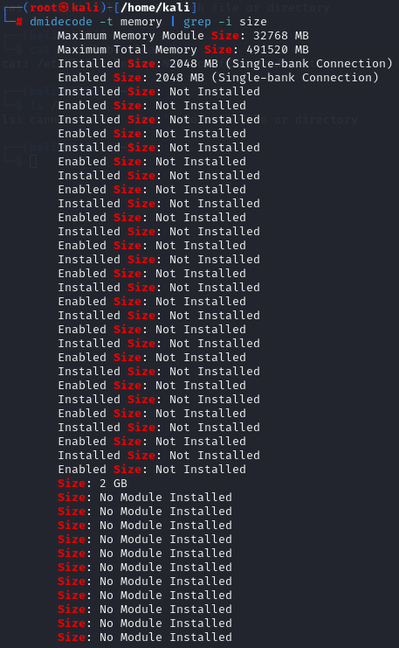

Task: To specifics on system memory, including type, size, speed, and voltage of each RAM

command: lshw -short -C memory

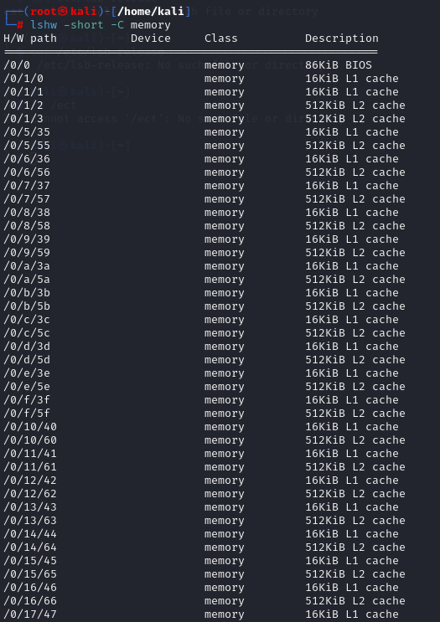

Task: To display free memory

command: free

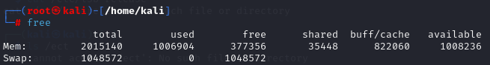

================

Hardware

================

Task: To Display PCI devices (Peripheral Component Interconnect network cards, sound cards, modems, extra ports such as Universal Serial Bus (USB) or serial, TV tuner cards and hard disk drive host adapters. )

command: lspci -tv

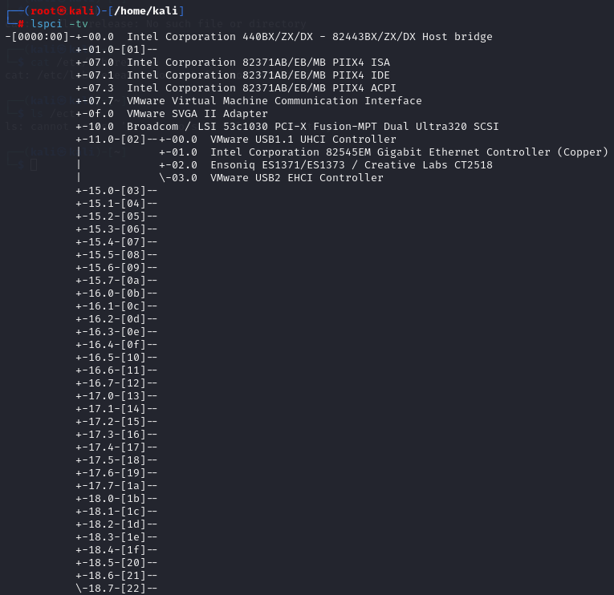

Task: To Display USB devices

command: lsusb -tv

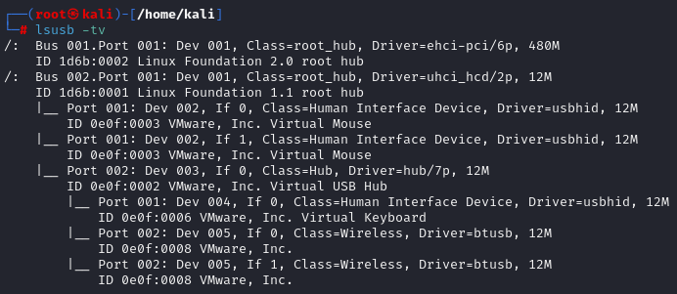

Task: To Display DMI/SMBIOS (hardware info) from the BIOS

command: dmidecode

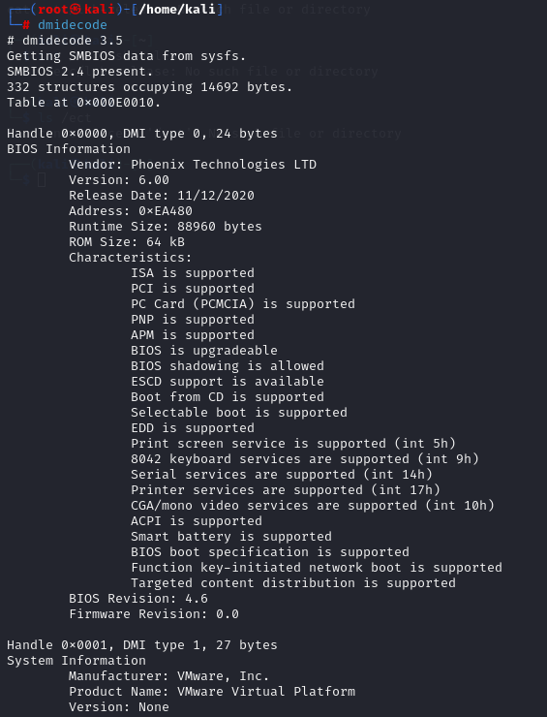

Task: To get hardware information

command: hwinfo



=======================

Disk Information

=======================

Task: To display a single line describing each disk device

command: lshw -short -C disk

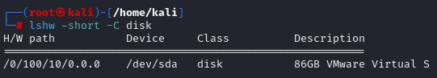

Task: To Show info about disk sda

command: hdparm -i /dev/sda

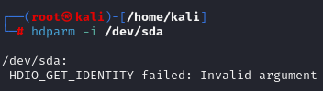

Task: To Perform a read speed test on disk sda

command: hdparm -tT /dev/sda

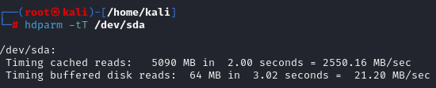

Task : To list model and serial numbers, supported modes, sector count, and more with:

command: hdparm -i /dev/sda



Task: To Test for unreadable blocks on disk sda

command: badblocks -s /dev/sda

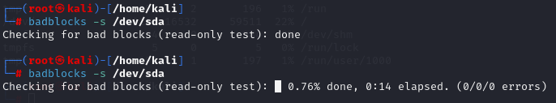

Task: To list all disks with all their defined partitions, along with the size of each

command: lsblk

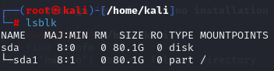

Task: To list the number of sectors, size, filesystem ID and type, and partition starting and ending sectors

command: fdisk -l

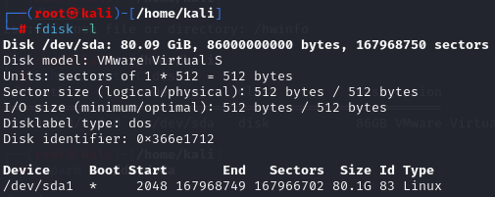

Task: To identify mountable partitions to the GRUB bootloader

command: blkid



Task: To display disk space usage

command : df

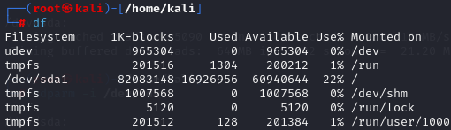

================

unsorted

================

Task: To show operating system information such as distribution name and version

command : cat /etc/os-release

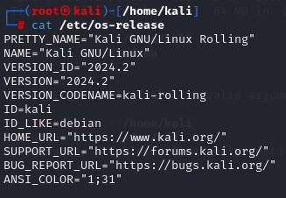

Task: To Display messages in kernel ring buffer

command: dmesg

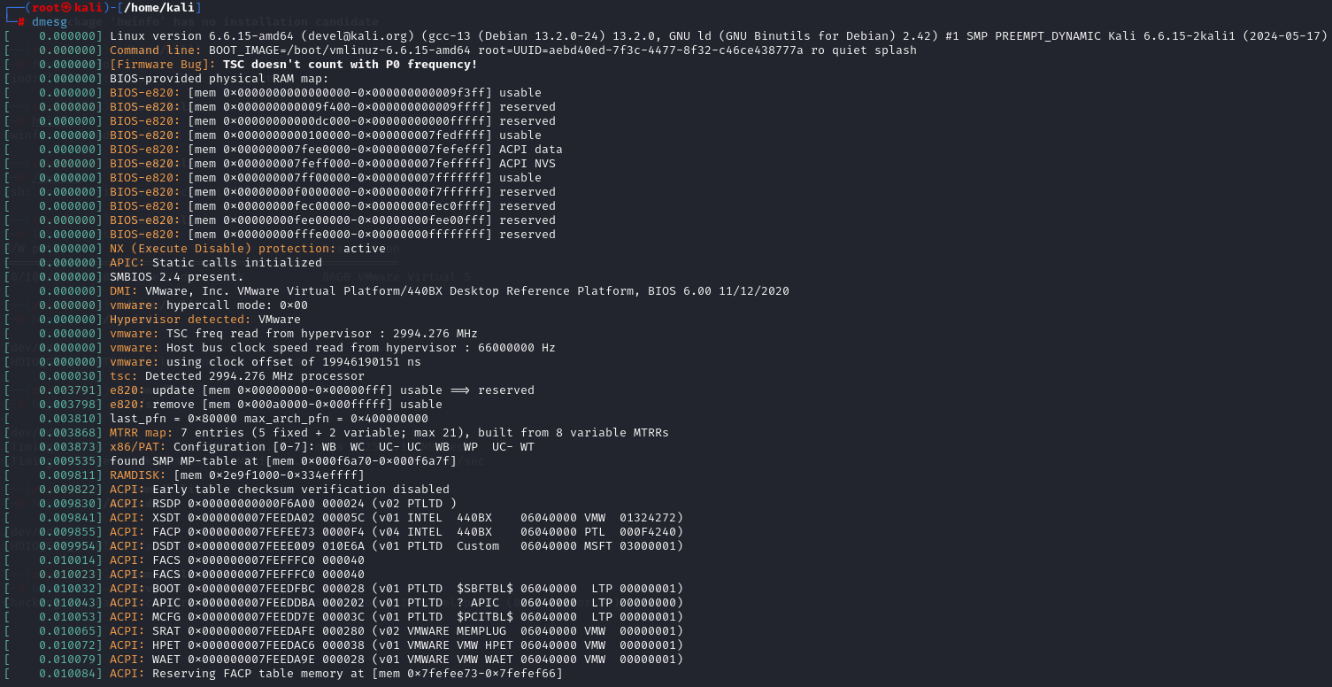

========================

File System

========================

Task : To list the mounted filesystems, their mount points, and the space used and available for each (in megabytes)

command: df -m

